**Block vs Inline Elements**

# Block Elements :

A block-level element always begins on a new line, and browsers add a margin (a space) before and after the element by default.

A block-level element always occupies the entire available width (stretches out to the left and right as far as possible).

<p> and <div> are two often used block components.

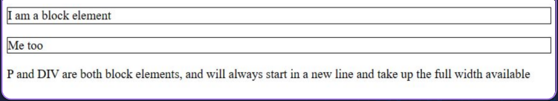

V

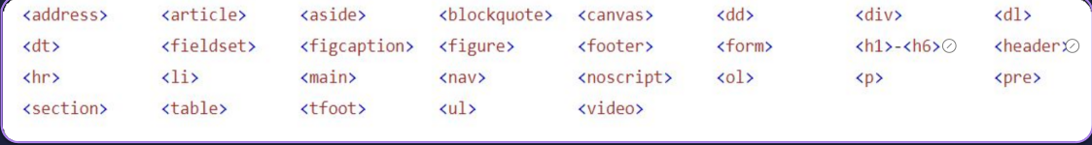

# Inline Elements :

A line break is not used to begin an inline element.

An inline element only uses the space that is required. An inline element cannot contain a block-level element

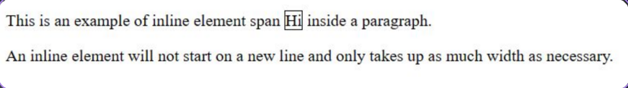

Other inline-elements are :

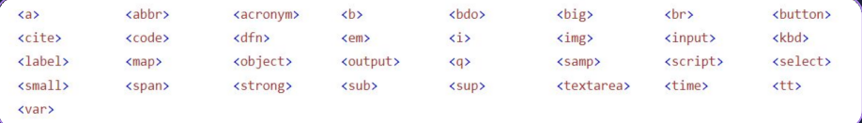

# <div> element

# 

**<span> element**

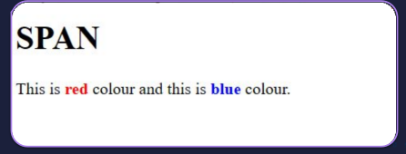

**THANK YOU**